Lab Assignment 1 Marin Aske
Query 1: List only the orders that have Speedy Express Shipping being shipped on the Lehmanns Marktstand.
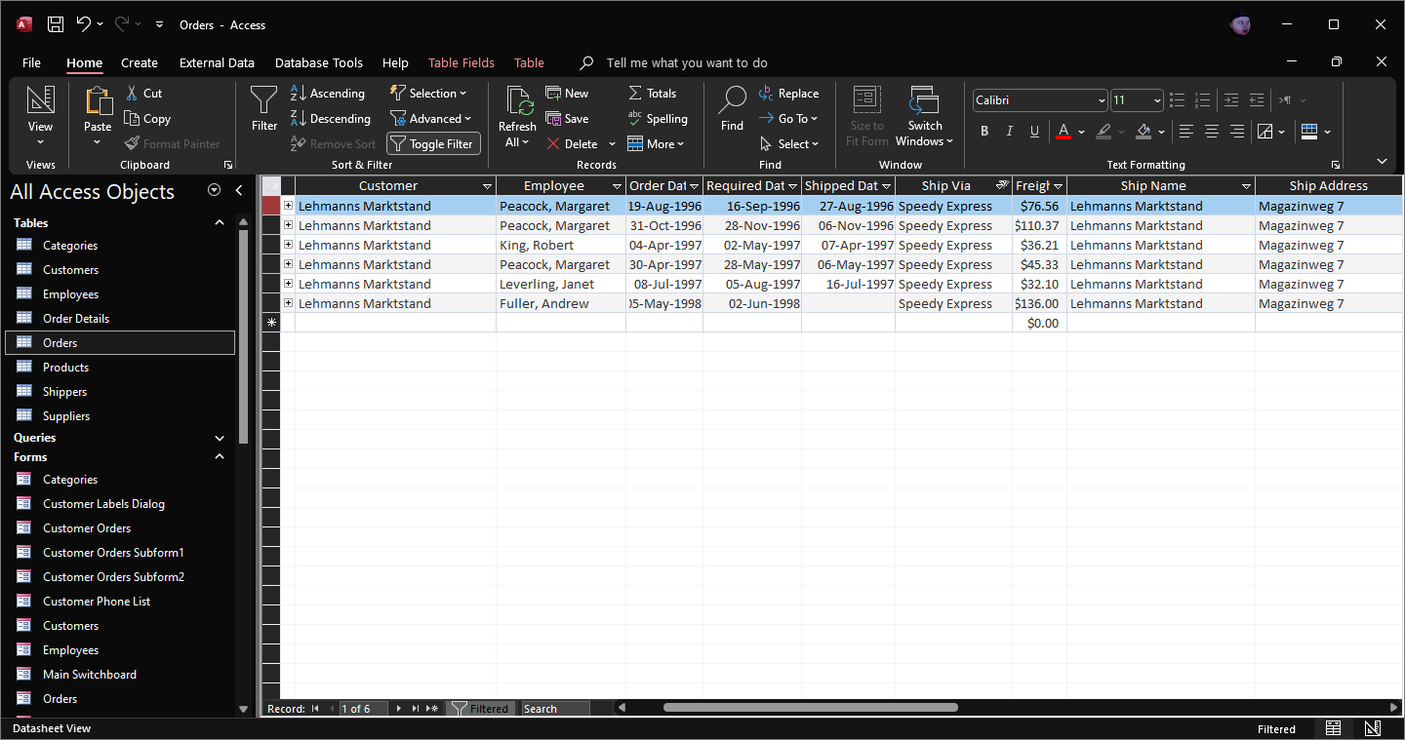

Query 2: Customers that used Federal Shipping and had their order shipped on the QUICK-Stop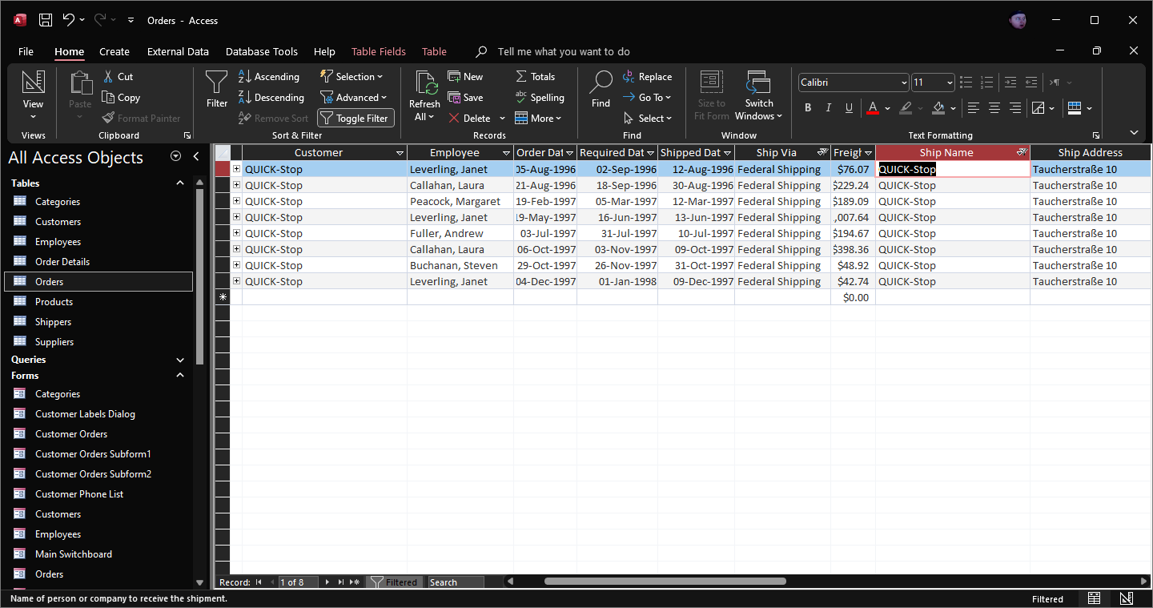

Query 3: List customers where the contact person’s title is Sales Agent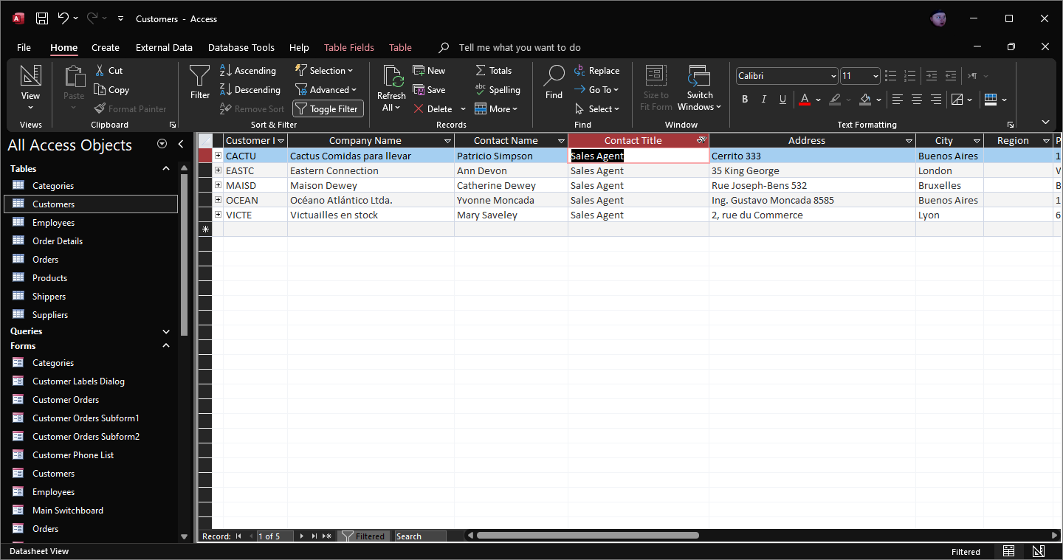

Query 4: List only the suppliers that are based in the USA and UK.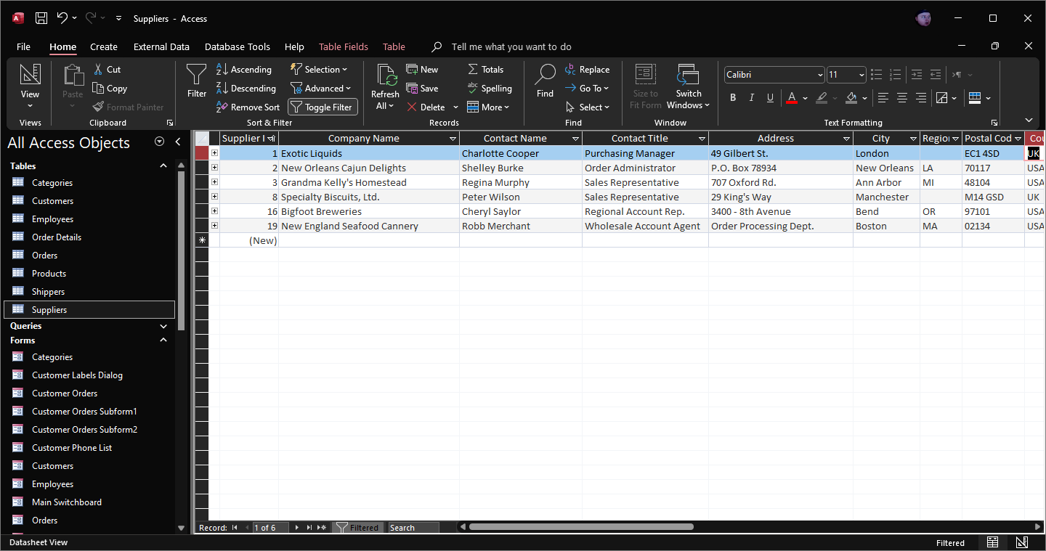

Query 5: List all products sold that are beverages.